**BME2104 -《生物医学影像技术》Home Work #2**

Due Date: April 17, 2024

***Note:*** *Please prepare your answers to the problems in a single PDF, and upload your PDF to Blackboard.*

* 1. Iodine-based agent is commonly used in X-ray and CT imaging to enhance contrast. Applying the physics principle of X-ray and matter interactions, and if the X-rays are of monochromatic energy at 60 keV, please find the answers to the following:
     1. What is the wavelength and frequency of 60 keV x-ray photon?(5)

**Ans:**

As known:

Now, we can use the Planck-Einstein relation to find the wavelength and frequency:

So,the frequency of 60 keV x-ray photon is

the wavelength of 60 keV x-ray photon is

, and its frequency is approximately.

* + 1. What is the relative x-ray absorption ratio of iodine to calcium which is the main element in bone? (5)

**Ans:**

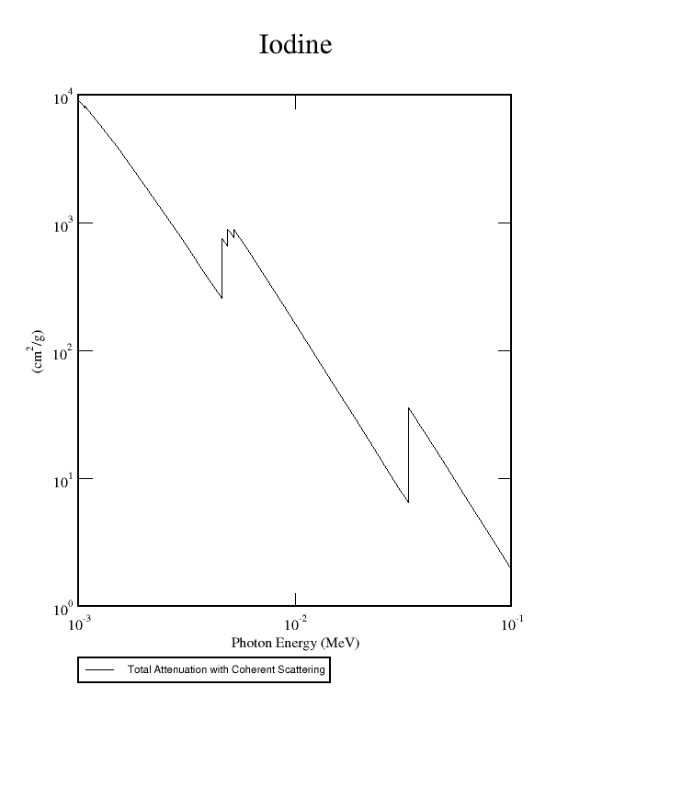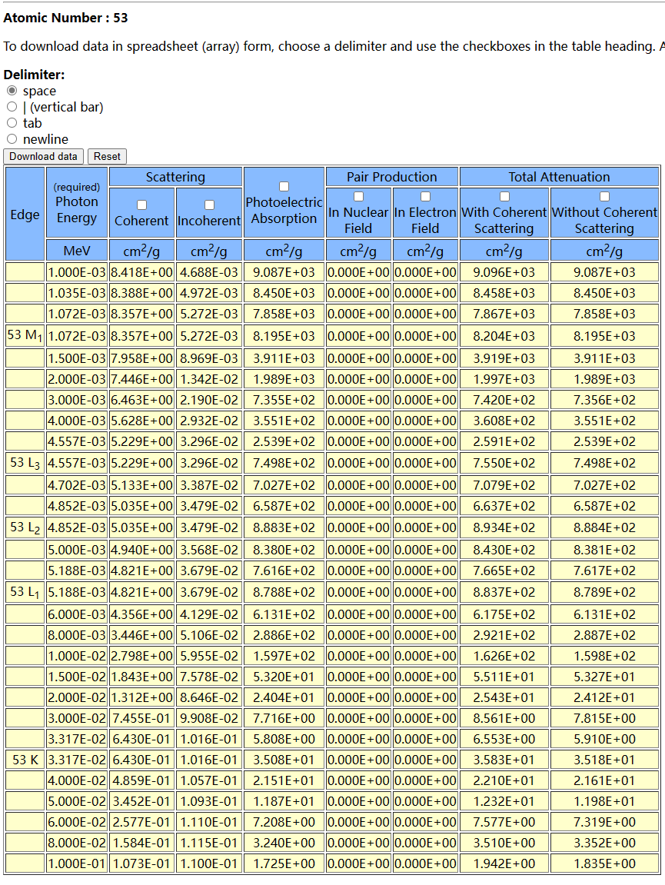

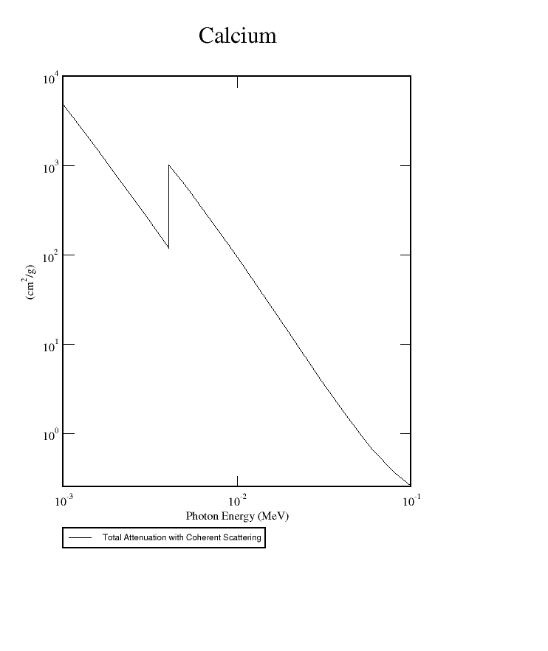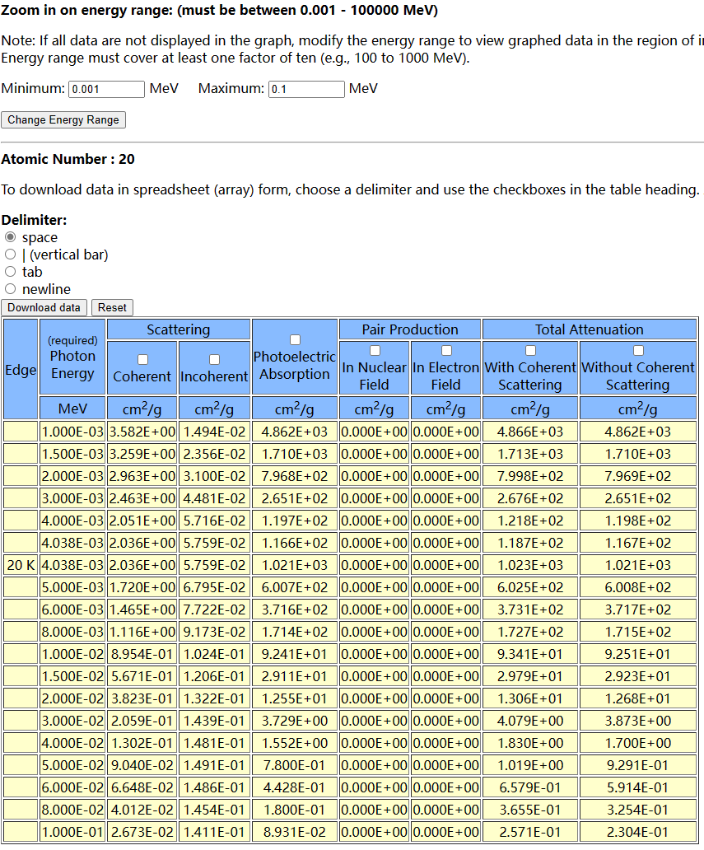

Given that total attenuation = absorption + scattering, according to NIST, when the X-ray energy is 60 keV, the absorption of iodine is 7.319E-00 ,the absorption of calcium is 5.914E-01

The absorption ratio of iodine to calcium is

* + 1. What is the K-edge absorption energy of iodine and calcium, respectively? (5)

**Ans:**

* + 1. At 60 keV, which one is the dominant interaction mechanism for total x-ray attenuation, absorption or scattering? Is there any chance of pair production at 60 keV? (6)

Absorption dominates X-ray attenuation at 60 keV.No

* + 1. When incident X-ray is at 60 keV, how does the energy of Compton scattered x-ray depend on the scattering angle? Write down your equation, and then plot the scattering photon energy versus scattering angle. (7)

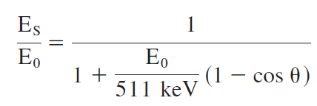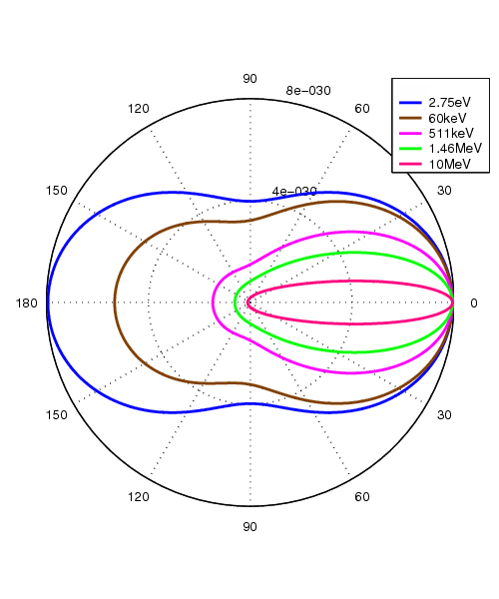

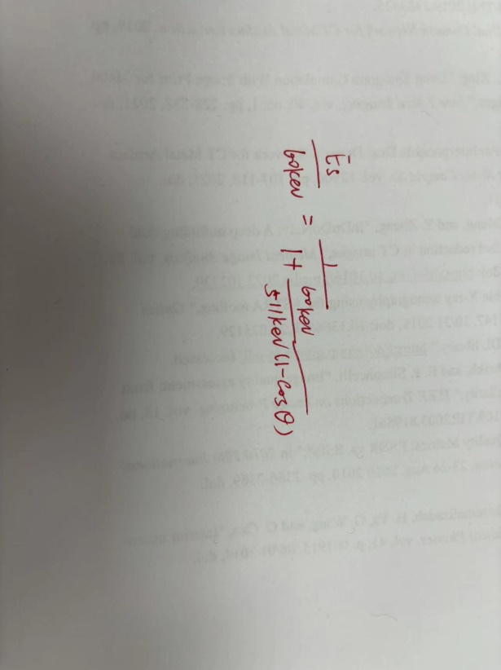

* 1. The spectrum from an x-ray tube is shown in the following figure. After the x-rays from this tube passed through a water cylinder (see right figure below), please sketch out the two expected x-ray spectra at the two positions (1 & 2). Please label those two spectra on the figure. You can superimpose your sketches onto the existing spectrum figure. (12)

|  |  |
| --- | --- |
|  |  |

The two expected x-ray spectra are shown in the below figure. The blue curve represents the spectrum of position 1 and the blue curve represents the spectrum of position 2. Since x-ray travels longer path through the water cylinder at position 1 than at position 2, the x-ray has more attenuation at position 1 than at position 2

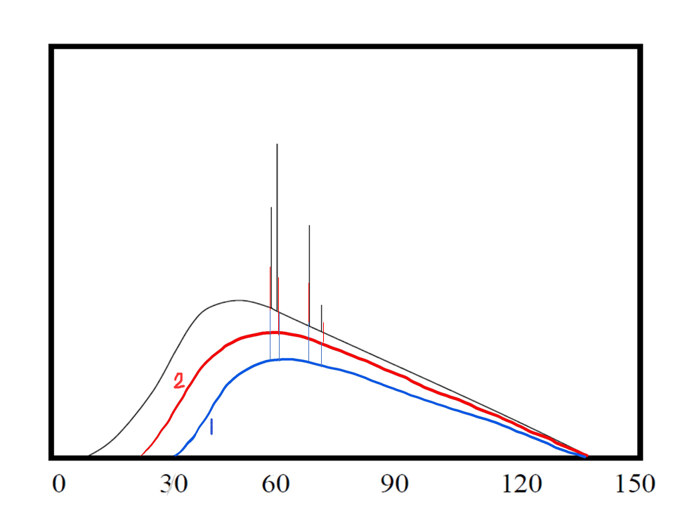

* 1. Use the following figure, explain the physics principle of Bremsstrahlung radiation, and how does Bremsstrahlung radiation contribute to the X-ray spectrum of an X-ray tube. (12)

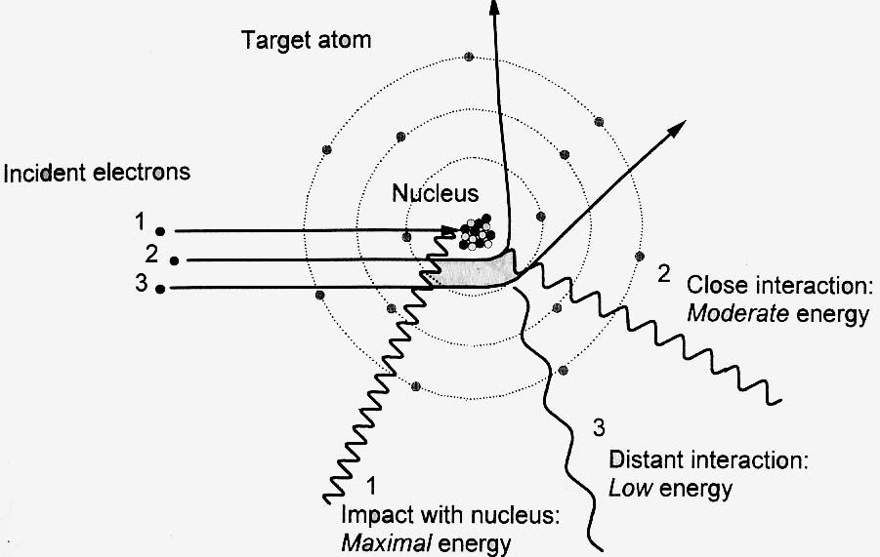

Bremsstrahlung is electromagnetic radiation produced by the deceleration of electrons.

Bremsstrahlung is the mechanism that produces a continuous X-ray spectrum because the energy loss of an incident electron is continuous under coulomb forces.

For Bremsstrahlung radiation, Kramers’ law governs the spectral distribution of x-ray photons vs. the wavelength.

* 1. What is characteristic X-ray of an X-ray tube? Please explain the physics principle behind characteristic X-ray. (12)

**Characteristic X-rays of an X-ray tube are related to the anode material. When electrons strike the anode in an X-ray tube, inner electron shells of the atoms in the anode are knocked out, and created electron vacancies. Those vacancies are then filled by electrons from the electrons of the outer electron shells, and in this process the energy difference between the inner electron shells and outer electron shells is converted into the characteristic X-rays.**

* 1. Is the following statement correct? Explain why. (12)

Statement: The total Bremsstrahlung output of an x-ray tube depends on both the anode material and the anode voltage.

correct

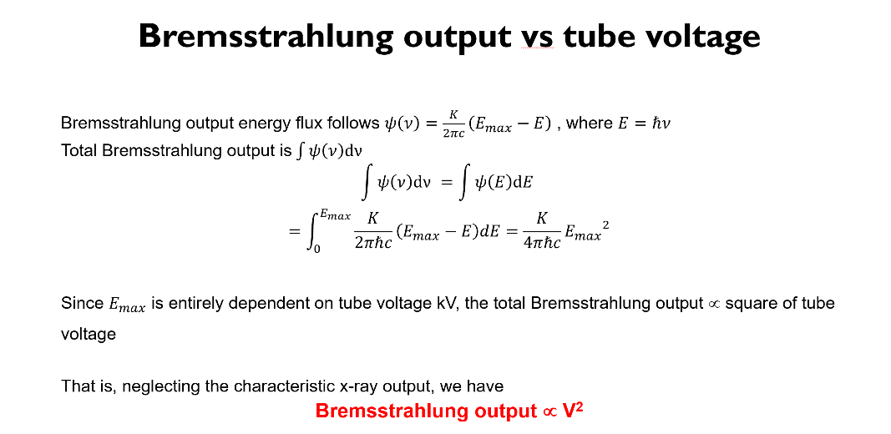

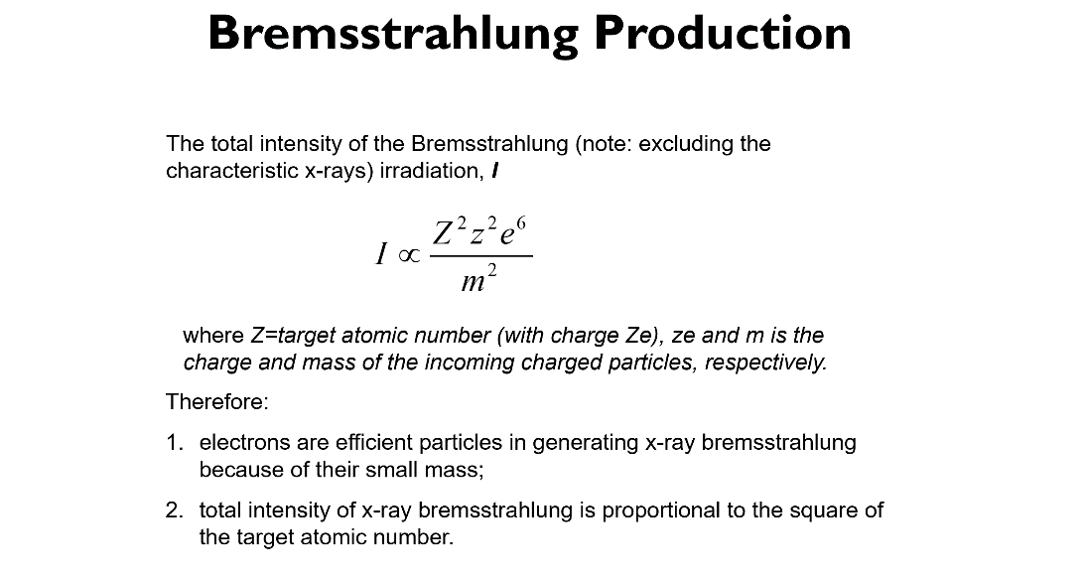

* 1. Based on the following graph, explain the line focusing principle, focal spot area, and effective focal spot. (12)

**In an X-ray tube, the area of electron bombardment on the anode surface is called focal spot area. As viewed through the line of sight of the detector (the direction perpendicular to the detector surface), the anode surface intersects with this detector line of sight at an angle that is called the anode takeoff angle (or simply anode/target angle), and the effective focal spot size that is experienced by the detector is related to the focal spot area via the following relation:**

**Effective focal spot size = focal spot area (at the anode surface) * sin (anode angle).**

**This relation is called the line focusing principle, because with it the effective focal spot size becomes smaller than the actual focal spot size on the anode.**



* 1. Based on the following graph, explain the cause of anode heel effect in an x-ray tube, and sketch out a possible x-ray intensity curve at the detector that shows the anode heel effect. (12)

**  
As is shown in the following graph, electrons produce photons inside the anode and some of the photons are created deep in the anode and they get absorbed within the anode heel. The probability of absorption depends on the distance the photons travel within the anode material, which in turn depends on the angle of emission relative to the anode surface. As a result, the X-ray beam has fewer photons on the anode side compared to the cathode side, so the cathode side has the higher intensity than the anode side.**

